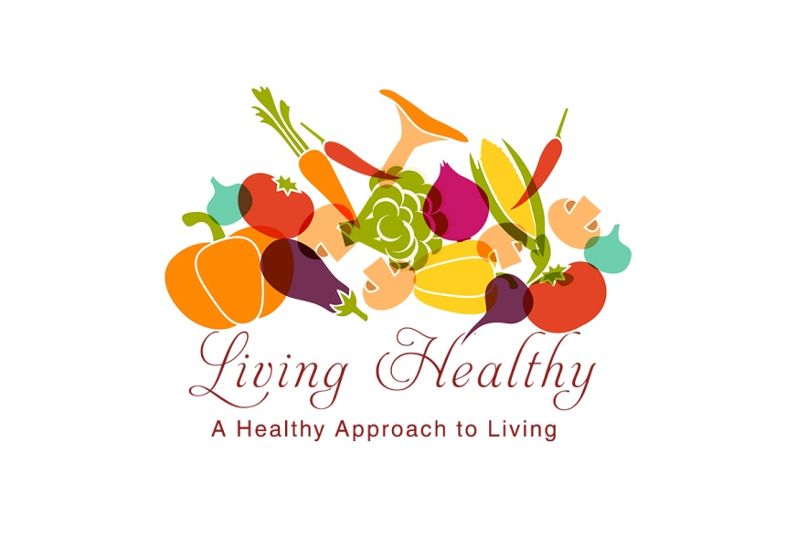

Living Healthy Daily Food Log

By Denine Rogers RDN, LD

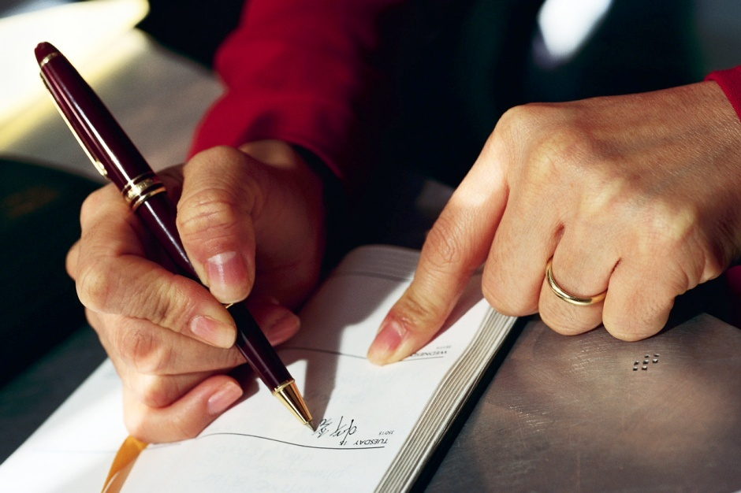
Congratulations for receiving your Living Healthy Daily Food Log and making the commitment to a healthy way of life. This Log should assist you in reaching your goals and in learning about your thoughts and feelings about exercise, eating and motivation. It was developed to conveniently record your life-changing program. The daily food log is a tool being used to recognize eating, behavioral and exercise triggers. Using this daily food log will enable you to renew yourself daily by taking control of your life. Each day, you should record the basic information of your thoughts, feelings regarding hunger, exercise, eating, thoughts about yourself, thoughts about people in your life, setbacks, triumphs or anything you desire.

How do you use this Daily Food Log?

To help you organize your daily food log, there is a list of things you can do:
- Write a goal in the goal statement for the month and what you will do to work toward them.
- Record your weight on the daily food log.
- Record the date and time you do the daily food log.
- Your general feelings about food, exercise and life.
- Record any good events or feelings you had during the day in the positive thought of the day section.
- Check off the glasses amount of water that you drink on a daily basis.
  - Fill out in detail the following information below in the Daily Food Log:
A. Record all foods and drinks (in the other section) consumed. Weigh
food portions by using measuring cups, spoons and food scale.
- Calculate the number of servings of each food item.
- Record the times you have eat the meals.
- Record the serving size amount for each food item and the description of the food.
- Record your exercise each day. Record in the time (the number of minutes), the type of activity, duration (how long it take you to finish the exercise) and distance. You need to aim 30- 40 minutes of aerobic exercise for approximately 4- 6 days per week.
- Record in the emotions column the thoughts you have when you eat the type of food. Theses emotions consist of anger, sadness, happiness, frustration and fear. Make sure that you write this in detail on how you felt when eating this food item and why you are eating this food.
- Write a Positive Thought of the Day. An example: “You can change the direction of your life…when you change your mind.” “It’s all up to you and your choices”. You can write other positive thoughts for other days in the Notes section.
WHAT IS A GOAL STATEMENT?

This is a personal statement based on correct principles become a standard for your self. It becomes a personal constitution, the basis for making life-directing decisions and daily decisions in the midst of the circumstances and emotions that affects your l
life. Setting goals, writing them down and monitoring them as you go along are all important steps that will help you get fit.

There are three types of goals:

1. Long-term goals involve the major activities or strategic changes that would take one to three years, which represent a bigger picture. One of your goals is the total amount of weight you want to lose to get to a healthier weight.

2. Intermediate-term goals are shorter than long –term goals but have a more realistic for this current period of time. This goal is a percentage of your long-term weight –loss goal. Example: Your long-term goal is to lose 50 pounds; your intermediate goal could be to lose 5 pounds.

3. Short-term goals cover a short period of time to realize your goals such as losing a pound in a week. These goals you can realistically focus on these goals every day. Short-term goals are all the steps that get you to your long-term goal.

Go to page _5_ Goal Statement Page to write your personal goals.

What is a serving size? *

ONE PORTION OF: | SERVING SIZE | IS ABOUT THE SIZE OF:
Meat | 3 ounces cooked | A deck of cards
Cheese | 1 ounce | A pair of dice
Potato | ½ cup | An ice cream scoop
Bread | 1 slice | ½ a bagel, ½ an English muffin, ½ a hamburger or hotdog bun
Cereal | 1 ounce | ½ to 1 cup depending on the type of cereal
Rice or pasta | ½ cup cooked | A very small bowl that side dishes are served in at a cafeteria
Salad dressing or gravy | 2 Tablespoons | ½ a ladle of dressing at a salad bar
Fruits and vegetables | ½ cup chopped, cooked or canned  1 piece | A very small bowl that side dishes are served in at a cafeteria  A medium apple or orange
Juice (fruit or vegetable) | ¾ cup | A small juice glass

* These serving sizes are the same as those on the Nutrition Facts food label.

Food Log serves two purposes. One is to shed light on what kinds of are being eaten, how much and the nutritional value of the food. The other purpose is to help the eater understand more about his or her eating habits and the things that trigger eating in order to develop a strategy for changing those habits and avoiding the triggers. For instance, if a diary shows eating are triggered by boredom rather than hunger, this is a signal to develop other ways of relieving boredom. If extreme hunger is the trigger, smaller, more frequent meals and light, high-fiber snacks might be the answer.

Keep your food Log for at least two weeks before making any changes in your diet. Try to find any unhealthful eating patterns that you can change or redirect. If you have trouble interpreting your food diary entries or need help coming up with a healthier nutrition program, consider making an appointment with a registered dietitian.

Studies show that a combination of sensible eating habits and regular exercise is far more effective than so-called “diets” in taking weight off and keeping it off.

The food log is your first step in establishing your food plan. You will find it surprising to see exactly what you eat. The goal to a personal food plan is to stay as close to your own eating style as possible. Your food log is important in helping design your food plan and in having a healthier lifestyle management plan.

Positive Thought of the Day

Exercise Log

Date | Time | Activity | Duration | Distance

Goal Statements:

Long-Term Goal_______________________________________________________________
_____________________________________________________________________________________________________________________________________________________________________________________________________________________________________________________________________________________________________________________________________________________________________________________________________________________

Intermediate-Term Goal_______________________________________________________
________________________________________________________________________________________________________________________________________________________________________________________________________________________________________________________________________________________________________________________________________________________________________________________________________________________________________________________________________________________________________________________________________________________________________________________________________________________________________________________________________

Short-Term Goal______________________________________________________________
___________________________________________________________________________________________________________________________________________________________________________________________________________________________________________________
_________________________________________________________________________________
_________________________________________________________________________________

Daily Food Log

Date______________

Water – 8 oz

MEALS Today’s Weight__________
Serving Size and Description

Time_____ Breakfast Emotions
Starch
Fruit
Milk
Vegetable
Other
Meat
Fat

Time_____ Lunch Emotions

Starch
Fruit
Milk
Vegetable
Other
Meat
Fat

Time_____ Dinner Emotions

Starch
Fruit
Milk
Vegetable
Other
Meat
Fat

Time_____ Snack 1

Time______ Snack 2

Time_____ Snack 3

Daily Food Log

Date______________

Water – 8 oz

MEALS Today’s Weight__________
Serving Size and Description

Time_____ Breakfast Emotions
Starch
Fruit
Milk
Vegetable
Other
Meat
Fat

Time_____ Lunch Emotions

Starch
Fruit
Milk
Vegetable
Other
Meat
Fat

Time_____ Dinner Emotions

Starch
Fruit
Milk
Vegetable
Other
Meat
Fat

Time_____ Snack 1

Time______ Snack 2

Time_____ Snack 3

Notes

Notes
Positive Thought of the Day
Positive Thought of the Day

